Stack and Heap Memory in a Multithreaded Recursive Program
[Your Name] — CS 660: Advanced Programming Language Theory
Southern New Hampshire University
[Instructor Name] — [Date]

Part One: Memory Diagram
fibonacci(int n) returns 0 for n = 0, 1 for n = 1, and otherwise fibonacci(n-1) + fibonacci(n-2). With n = 2 it makes two child calls, fibonacci(1) and fibonacci(0), evaluated one at a time and summed to 1, so the recursion reaches only two frames above Worker.run(). main() builds three Worker objects (threadId, n = 2), wraps each in a Thread, starts all three, and joins them. Figure 1 shows memory at the moment each thread sits at its deepest frame.
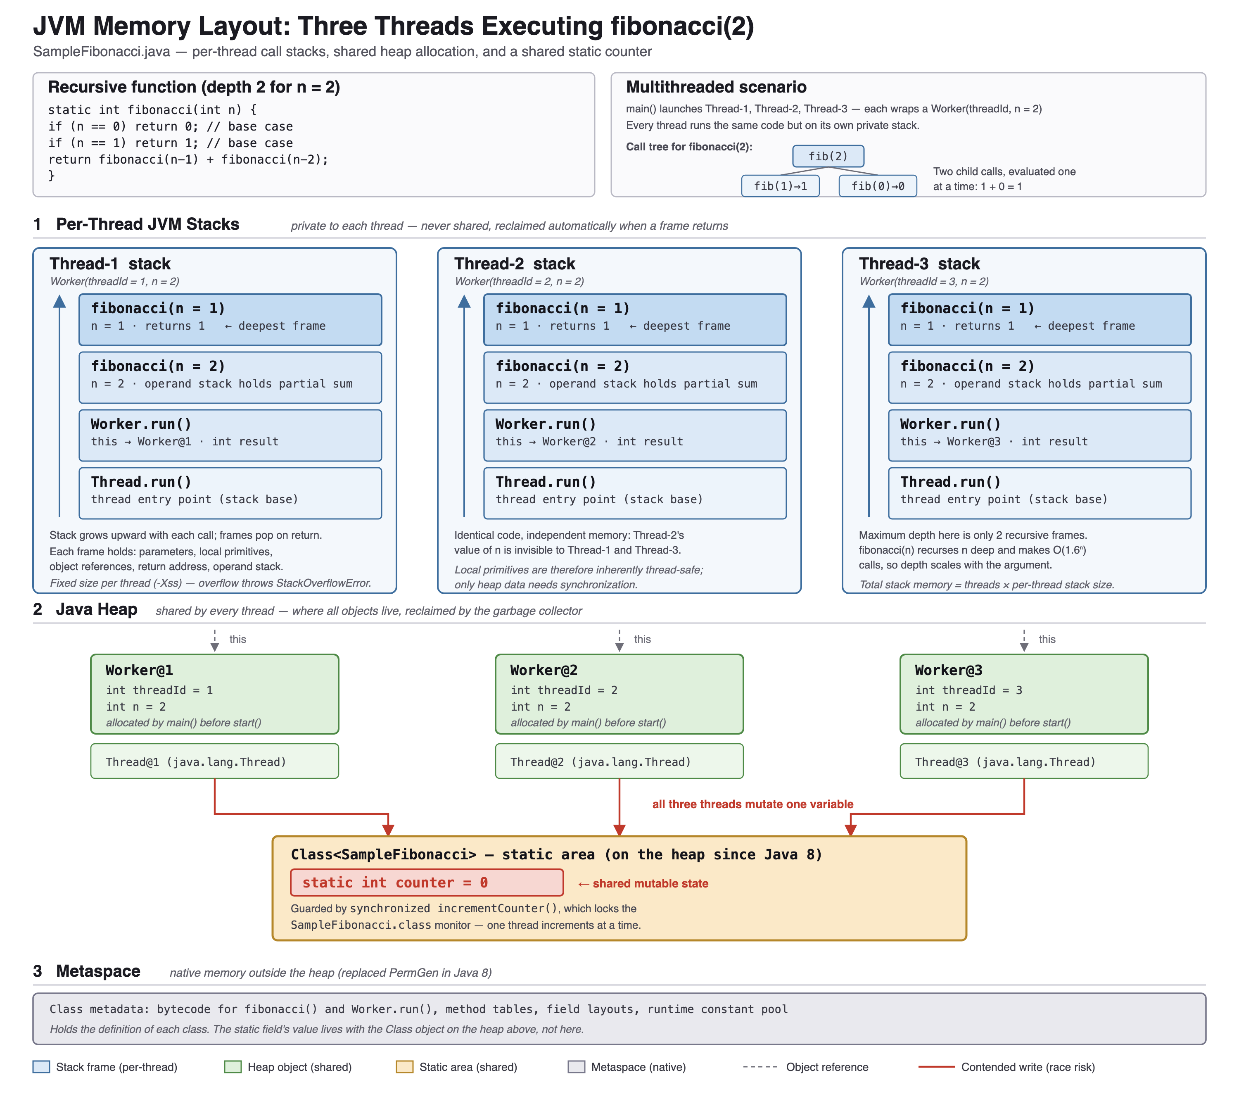
Figure 1. JVM memory during three concurrent fibonacci(2) calls. Dashed arrows are references from a stack into the heap; red arrows mark the single contended write.

Part Two: Reflection

Role of each labeled region
Each thread owns a private stack (region 1) with one frame per invocation, holding that call's parameters, local primitives, object references, return address, and operand stack. Because n and result are primitives they live entirely in the frame, which is destroyed on return without collector involvement. The heap (region 2) is shared and holds every object — three Worker and three Thread instances — and each Worker.run() frame's this reference points from a private stack into it. The static area within the heap holds counter: one copy per class rather than per instance, stored with the Class object since Java 8. Metaspace (region 3) is native memory outside the heap holding class metadata such as bytecode and method tables.

Why constraining stack growth matters
Each stack is a fixed reservation (-Xss, commonly 512 KB to 1 MB), which bounds recursion depth: fibonacci(n) recurses n deep, and a large n throws StackOverflowError, which cannot be handled meaningfully. This function's cost is exponential in calls but only linear in depth, so it is n, not call count, that threatens the stack. At scale the sharper limit is that total stack memory is threads times stack size — a thread-per-request server with 1,000 threads reserves roughly a gigabyte before doing any work — which is why production systems bound recursion and use thread pools.

A concurrency risk revealed by the diagram
Three private stacks converge on one shared cell: static int counter. Everything above it is thread-confined, so counter is the only contended location. counter++ is a read-modify-write, and interleaving two of them loses an update; synchronized incrementCounter() prevents exactly that. The diagram exposes a subtler defect, though: run() reads counter again in its printf call, outside the lock. That read has no happens-before relationship with other threads' increments, so it may see a stale value, and another thread can increment between this thread's increment and its read. The increment is atomic; increment-then-report is not.

A synchronization technique that solves it
Widen the critical section so the increment and the read of its result are one atomic step. The minimal change returns the new value from inside the lock:
public static synchronized int incrementCounter() {
return ++counter;
}
run() then prints that returned int — a local in its own frame, and therefore thread-confined. AtomicInteger.getAndIncrement() is an alternative, performing the same read-modify-write as one lock-free compare-and-swap and scaling better because threads never block. Either way, the unit of atomicity must cover the whole invariant, read together with write, not the write alone.
Note on generative AI use: [Adapt or remove per your course's AI policy — see the assignment's AI Usage section and the Shapiro Library citation guide.]

